02.55 KEY AUDIT MATTERS

The following describes the functionality and features included in Probe Audit Premium+

Objective

The objective of this document is to determine, from the matters communicated with those charged with governance, the key audit matters to be communicated in the auditor’s report in accordance with ISA 701.

The following key concepts of the Probe Audit Premium+ Methodology are set in this document:
- Identification of key audit matters from matters communicated with those charged with governance (ISA 701)
- Application of professional judgment to determine matters requiring significant audit attention
- Communication of key audit matters in the audit report for public interest entities

Document placement

Document 02.55 – Key Audit Matters can be found in the Finalisation folder in the Caseware document manager.
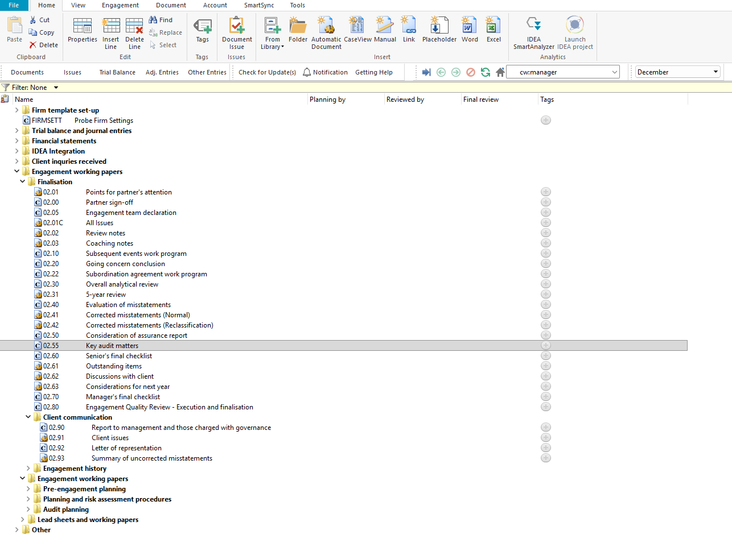

Document content

This document is designed to be a checklist type document that guides the engagement team through the procedures required to determine and document key audit matters in accordance with ISA 701.

This document is divided into different bookmarks in the document map to assist you in completing the key audit matters evaluation:

Procedures

Conclusion
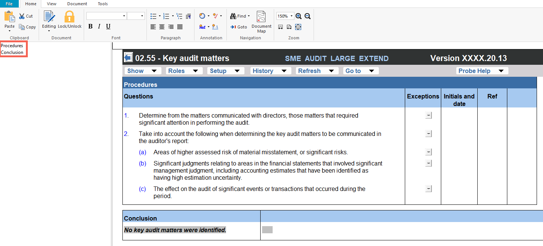

Layout
Column | Input Required | Outcome
Procedures
Questions | No input is required in this column. The procedures are pre-populated and guide the engagement team through the steps required to determine key audit matters from the matters communicated with those charged with governance. | No impact on the engagement file. Documents the procedures to be performed when determining key audit matters.
Exceptions | Enter any exceptions or findings identified during the performance of each procedure. | No impact on the engagement file. Documents the exceptions identified for the engagement file.
Initials and date | Enter the name or initials of the engagement team member who performed each procedure and the date of performance. | No impact on the engagement file. Records who performed each procedure and when the procedure was performed.
Ref. | Enter a cross-reference to the relevant working paper or supporting documentation for each procedure. | No impact on the engagement file. Documents the cross-reference for the engagement file.
Conclusion
Conclusion | No input is required in this column. The conclusion is pre-populated based on the outcome of the procedures performed. The default conclusion states that no key audit matters were identified. | No impact on the engagement file. Documents the conclusion regarding key audit matters for the engagement file.

Document outcomes

The engagement team must perform the procedures to determine, from the matters communicated with those charged with governance, those matters that required significant attention in performing the audit. The engagement team must consider areas of higher assessed risk of material misstatement or significant risks, significant management judgments relating to areas in the financial statements, and the effect of significant events or transactions that occurred during the period.

The engagement team must document the conclusion regarding key audit matters. The conclusion is pre-populated and states that no key audit matters were identified. Where key audit matters are identified, the engagement team must document these accordingly and ensure they are communicated in the auditor’s report in accordance with ISA 701.

Group Audits

When the engagement type was selected as 'Group Audit Single' or 'Group Audit Multiple', the key audit matters document applies to the group engagement. The engagement team must evaluate the key audit matters for the group financial statements and ensure the auditor’s report reflects the group audit requirements, including references to component auditors where applicable.

IN CONCLUSION

Features

The following features are available in the document:

Insert or delete a comment, see page F3

Guidance, see page F16

Freeze, see page F19

